Ben’s Bogan Adventures  
GDD

**Overview**

**Product Details**

* Players
  + Single Player
* Genre
  + 2D Platformer, Adventure
* Platform
  + PC/Switch
* Outlets
  + Steam, Nintendo Store, Epic

**Summary**

Casual RPG, Player plays the role of Ben, who has to make it to work on time, his car has broken down and the trains too, he has to catch a series of buses to get to work and comes across colourful characters that could help him get there on time or delay him.

**Pillars**

* Australian Cultural Encounters
  + Each character that Ben encounters represent Archetypal Australian figures (E.g. Bogan, Larrikin, Ocker, Eshays etc…)
* Time Management
  + A constant reminder that Ben does not have a lot of time to get to work, shown through as a clock ticking from the current time to when he needs to be at work.

**Unique Selling Points**

* Introducing/re-introducing Australian culture that once had a strong interest during the 80’s – 90’s (the social aspects)

**Target Market**

We are reaching a market that reaches out to Australians as a self-reflection (if a light-hearted one at that) of their culture, but also reaching out internationally for those that are curious to the finer nuances of Australia and its social.

* Casual Players
* Players that enjoy Australian social culture
* Platformers
* Local Australians

**Game Loops**

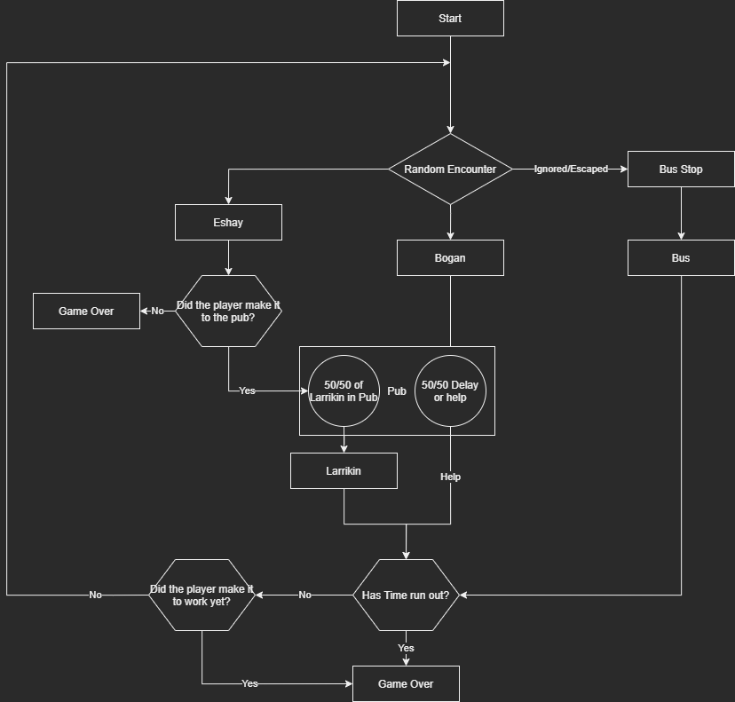

**Mechanics**

* Movement & Camera
  + On PC; It is either WASD or Arrow Keys to control movement and E for interaction
  + On Switch; The left keypad controls movement and the right pad A for interaction
  + Camera constantly follows the player
* Dialogue
  + Dialogue interaction for the player to chose what happens next, whether he will have time for a chat or ‘have’ to be rude and leave the dialogue early
* Menu
  + A simple menu system dealing with options such as play, pause, sound
* Interaction
  + It only requires a press to interact or dialogue with the same key press E/A

**Systems**

* Time
  + The player will have a clock indicating how much time he has left to get to work on time
* Transport
  + Buses that the player can catch will get him there and closer on time but there can also be special characters that can get our player closer to work

**Controls**

* PC
  + Keyboard: WASD/Arrow Keys for direction, SpaceBar for jump and E to interact
* Switch
  + Right keypad controls movement
  + Press ‘A’ to interact

**Key Characters**

* The player will encounter 3 different types of Australians, The Bogan, The Larrikin and the Eshays
  + The Bogans will try to goad the player to speak with them for a bit and join them at the pub with the promise of helping the player
    - The Bogan character has a 50/50 chance of the helping the player or passing out at the pub
  + The Eshays will at random points of time appear as an encounter to the player and chase them down, if they catch up to the player, it is game over and Ben gets “rolled”
  + The Larrikin may appear at a pub and offer the player a helping hand, or if the player is really behind time, the larrikin by chance appear to the player to get them to the next bus stop

**Enemies**

The Eshays are the only enemy here, and encountering them means a chase and if they catch up to the player, the player will lose the game and start again

**Player Progression**

The time shown with the distance travelled and distance to go will be the players indication of their progress.

**Level Design**

There are several levels, starting with the player at the Train station and finding out the trains are not running, then there is the general out west suburb area the player traverses to get to the buses so they can get to work on time and then there is the last level which is the work place, there are rest points and chance points in between, buses being rests and pubs being chance point for the player to get a push forward

* Home
  + The Player will awake at home and be seen getting ready for work only to find out that the car has broken down and they have to catch a train
* Train Station
  + The player must now catch the first bus after finding out that the trains are now working and they encounter their first enemy in which the player has to run to the bus stop, also, they must make sure they get the bus on time
* The Streets
  + The street is the main playing area for the player and chance encounters and it is linear
  + There are different street environment to indicate the different suburbs the players travels through to get to work and each streets difficulty is increased with better chances of encounters with enemies and random characters
* The Bus
  + This is a resting and transition point for the player until the next area
* The Pub
  + The pub is the players point of chance to getting to the nearest or skipping a few bus stops to help them along the way to work thanks to the Larrikin character if they are at that particular pub
* Work
  + This is the players destination, if he makes it, the player has successfully made it on time and the boss commends the player for it, only to be told afterwards that it’s a Saturday and that they should go home
  + **If the player is unsuccessful, the player will have lost their job, not only was it a Saturday and is marked as being inattentive but also being late is not a good sign.**

**Puzzles**

The puzzles are mostly down to player chance of the type of encounter they will have. And it comes down to dialogue choice and what happens at the pub if the player choses to go there.  
  
If the player choses to only catch the bus and dismiss all encounters and offers, the player will not make it on time, the buses are slower than if the player had been given a ride.

**Themes and Story**

The theme of this game is to show mostly the types of characters that exist in Australia, from very helpful characters, some that have good intentions but lack follow-through and characters that yes unfortunately are delinquents and display their unique Australian nuance through dialogue in slurs, slangs, phrases and sayings. And how the player can deal with them, imparting along the a unique aussieness about them

**The Story**

Ben is starting a new job, and as he wakes up and gets ready, he finds that his car has broken down and must take the train, but they are also down (trackwork) so Ben must catch the bus to get to work on time but he has to catch connecting busses to do so, while now being chased by Eshays along the way, he encounters a few Bogan individual that invite Ben for a chat or drink at the local pub with the promise of helping them get to their job, but some may be able to help, others will unfortunately not be able to, in certain pubs Ben meets with an Larrikin character that offers them a ride and helps Ben skip a few bus stops but they can never take Ben all the way to his Job.  
  
Along the way, Ben will constantly be chased down by the group of Eshays that he encountered at the train station, if they catch up to Ben, he will be robbed and then lose his job.  
  
At his Job, if Ben makes it on time, the boss will be impressed at the initiative the Ben has displayed but also remind him the it is Saturday and appreciates him volunteering his time.  
  
If Ben is late, the boss will be less than impressed, proving the difficulty of someone being on time for work and for the fact that they can not be more attentive at the fact that it is a Saturday and may not be the best for the job.

**Art Style and Aesthetic**

* Colour Palette
* Character Art Style
* Lighting

**Sound**

* Music
  + 8 bit chiptunes with maybe some well known Australian medleys thrown in
* SFX
  + Footsteps
  + Menu click sounds
  + Ambient sound (Train, Pub, buses)

**Revision History**

|  |  |  |
| --- | --- | --- |
| **Version** | **Date** | **Details** |
| 1.0 | 15.04.2021 | First Document (Paper) |
|  |  |  |
|  |  |  |
|  |  |  |
|  |  |  |
|  |  |  |
|  |  |  |